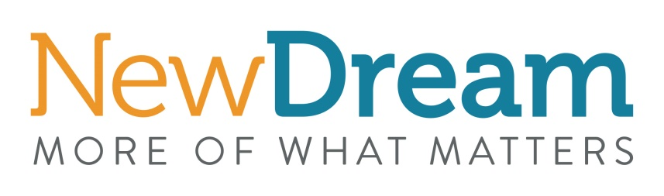
Experiential Gift Survey and Pledge Promotional Examples

Survey and Pledge

Newsletter blurb:
Giving Memories Instead of "Stuff"
What are the barriers to and benefits of experiential gift giving? New Dream's social and behavior change fellow, Kelley Dennings, hopes to answer that question. Kelley has spent years studying and working at the intersection of environmental science and social and behavioral change. In June 2017, she launched a pilot project for New Dream exploring people’s motivations, perceptions, and thoughts around reducing personal consumption as part of her master’s thesis.

Support the project by participating in this 8-10 minute survey (https://www.surveymonkey.com/r/NDBBAAFF) exploring the attitudes, barriers, and benefits associated with experiential gift giving. At the end of the survey click the link to pledge to simplify your holiday’s this winter by giving one experiential gift instead of a material gift. This will increase the happiness and well-being of someone you care about and protect the environment through decreased consumption. Please feel free to share this survey with others.

For more details about Kelley’s project click here (https://newdream.org/blog/what-would-it-take-to-shift-our-gifting-away-from-stuff?)

If you or your organization want to help promote these topics (decreasing consumption, increasing happiness, spending more time in nature and with family and friends, etc.) please contact Kelley (kelley@newdream.org). She can provide you with sample social media posts, newsletter content or she can discuss a larger partnership. The campaign is being conducted pro-bono with no funding so any in-kind support is greatly appreciated.

Social media posts:
Participate in this 8-10 minute survey (https://www.surveymonkey.com/r/NDBBAAFF) by New Dream to explore the attitudes, barriers, and benefits associated with experiential gift giving. At the end of the survey click the link to pledge to simplify your holiday’s this winter by giving an experiential gift instead of a material gift. This will increase the happiness and well-being of someone you care about and protect the environment through decreased consumption.

Pledge only:

Newsletter blurb:
Spread happiness!
Pledge to give at least one experiential gift this holiday season. Make the commitment here: https://newdream.org/simplify-the-holidays-pledge.

An experience is a fun and memorable gift, and can be anything from taking a bird identification class to attending a comedy show with friends. Research shows that experiences are special because they can be unique, the associated anticipation increases enjoyment, they provide long-lasting memories, they are fleeting so we value them more, and their value increases with time.

After signing the pledge New Dream will send you three e-tips between now and the end of the year with tools, hacks and gift ideas to help make experiential gift giving and receiving easier and more fun. You can opt out at any time. Help spread the happiness by sharing this pledge with others!

By choosing to give an experiential gift instead of a material gift, you will increase the happiness and well-being of someone you care about, and protect the environment through decreased consumption.

Social media posts:
Participate in New Dream’s Simplify the Holiday pledge (https://newdream.org/simplify-the-holidays-pledge). An experience is a fun and memorable gift, and by choosing to give an experiential gift you will increase the happiness and well-being of someone you care about and, protect the environment through decreased consumption. Help spread the happiness by sharing this pledge with others.

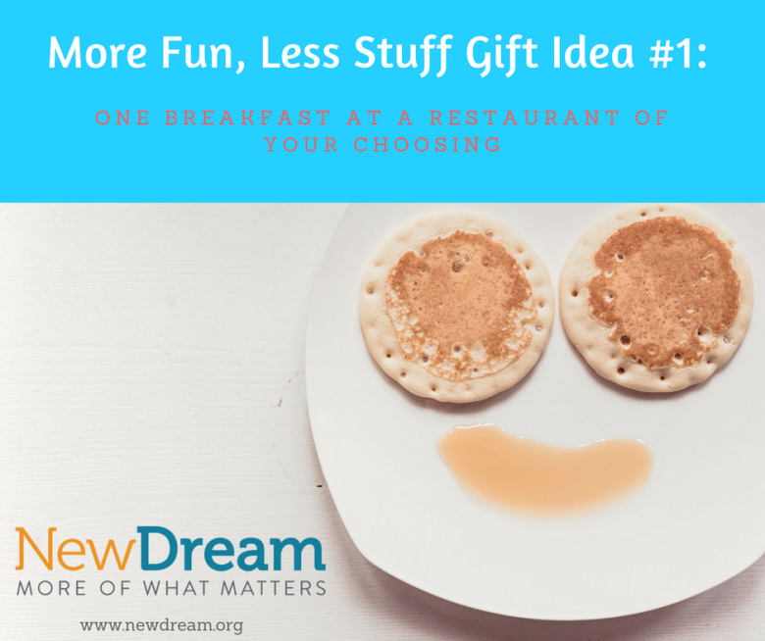

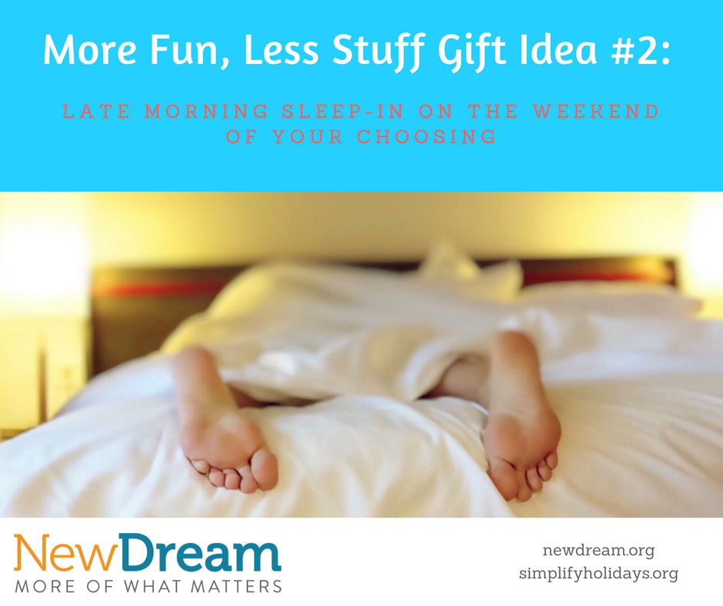

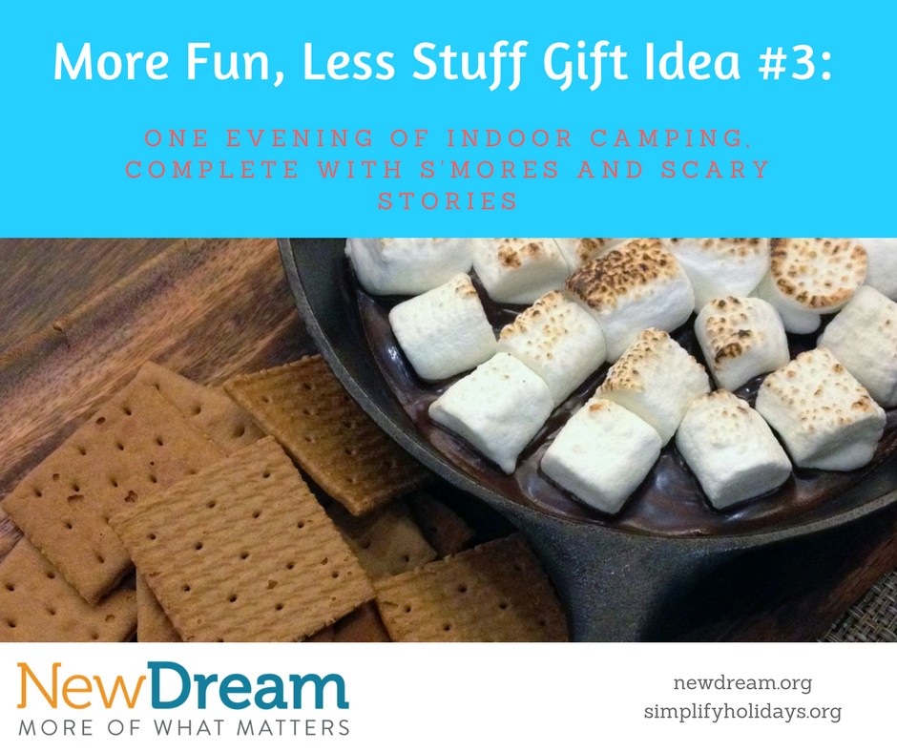

Download png’s of these memes here –
https://drive.google.com/open?id=1EfPhDyz2Wv-mEm9aIXEQZeYKOVsDx5Fh

